LabWork 2

Prerequisites:

At least 1 running SQL server

At list 2 attached not system disk in the OS – to place users DBs files (ALL files of custom DBs)

Tools to work with SQL server

Pay attention to best practices and performance optimization for SQL server and databases.

Tasks:

1. Reconfigure TEMPDB to another database files location and options (use custom folder):

**Main DB file:**

Size: 10 MB

File growth: 5 MB

Maximum size: Unlimited

File location: on the attached disk

**DB log file:**

Size: 10 Mb

File growth: 1 MB

Maximum size: Unlimited

File location: on the attached disk

Restart SQL to apply changes

Delete old files

Проверяем текущие значения

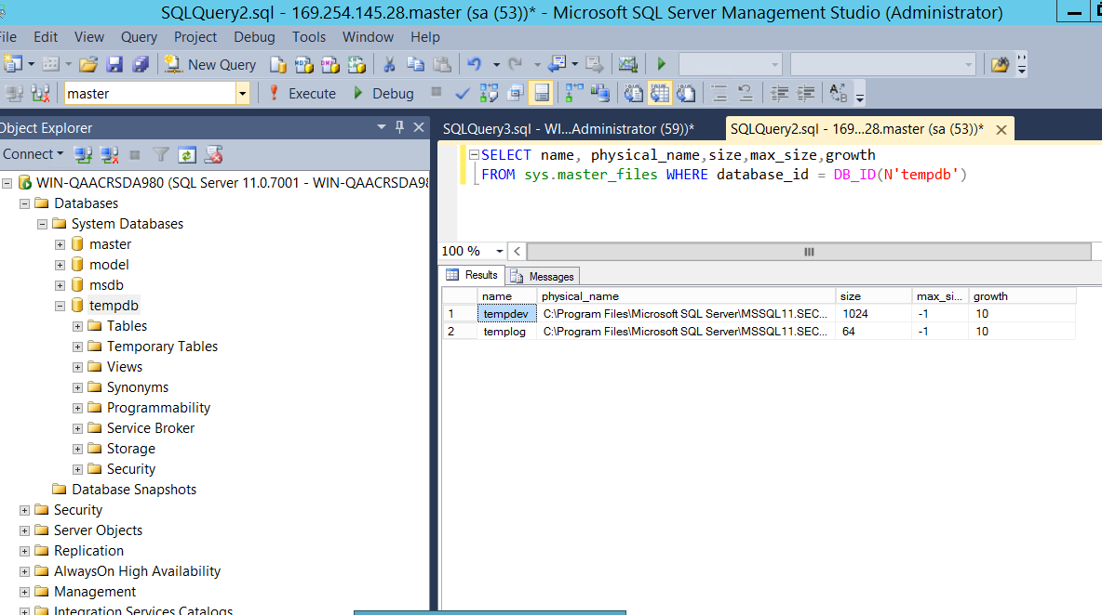

Смотрим расположение файловВносим требуемые изменения через SQL запрос с изменением местоположения файлов

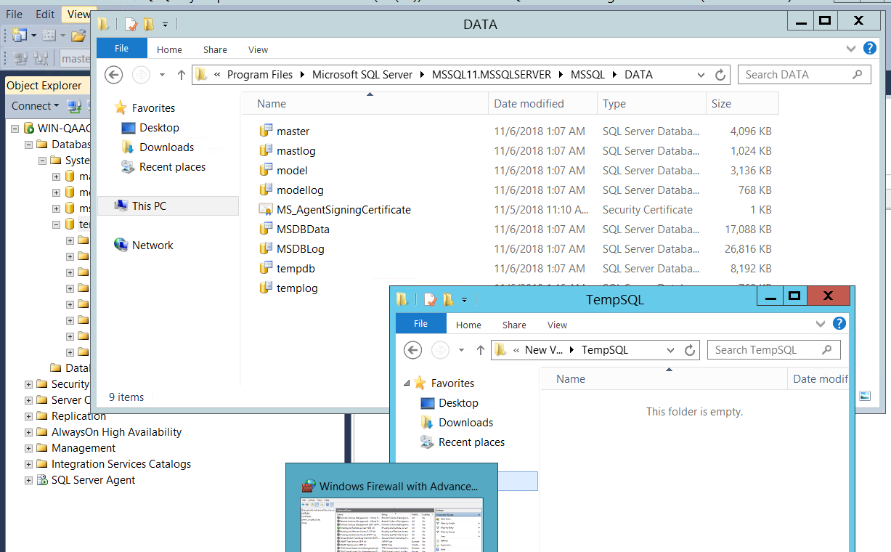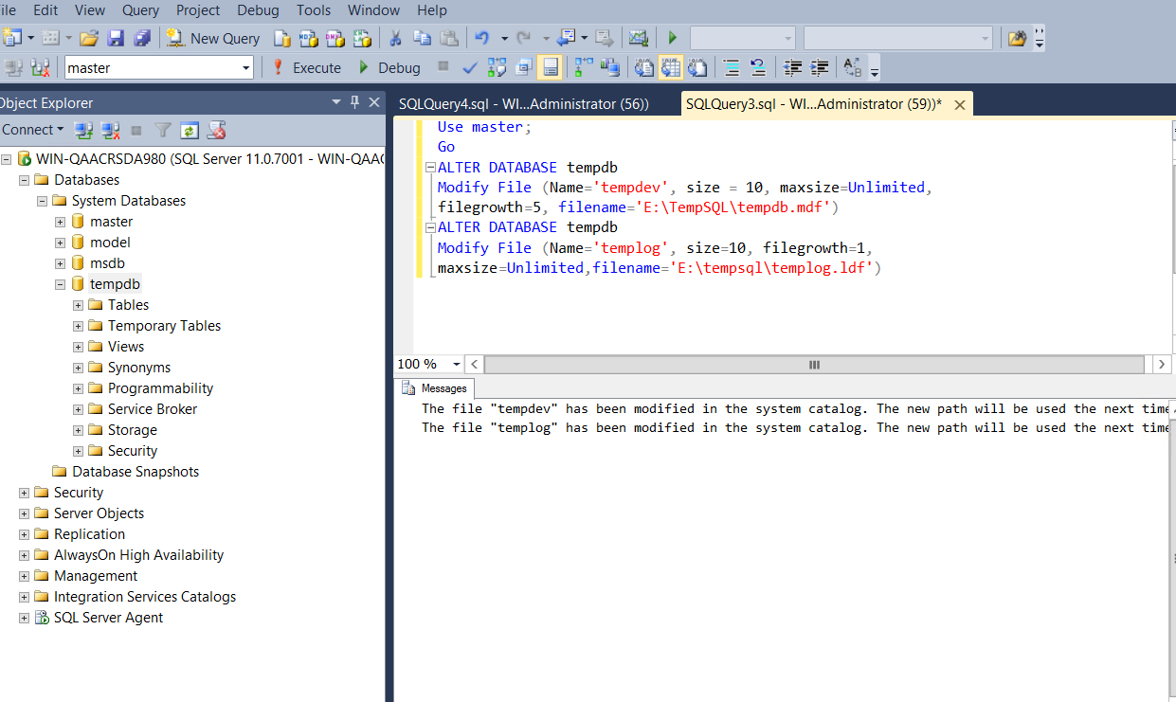

Останавливаем MSSQLServer

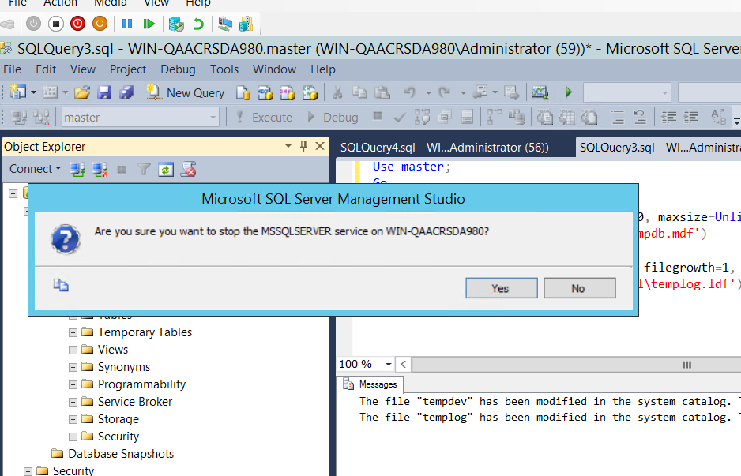

Удаляем исходные файлы tempdb.mdf and templog.ldf

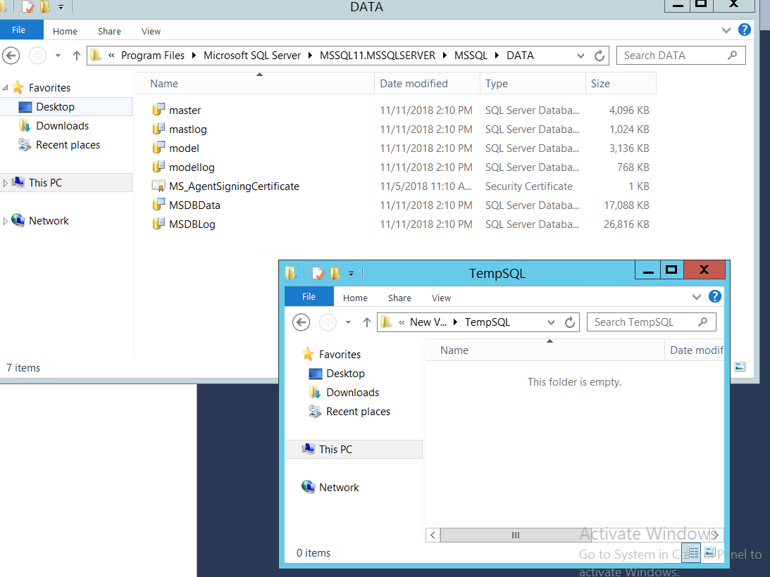

Запускаем службу и смотрим текущие параметры

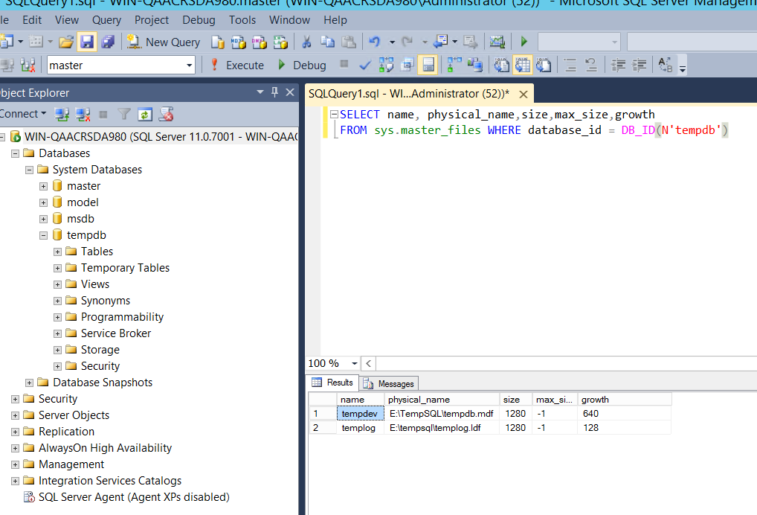

Смотрим появились ли новые файлы в новой директории

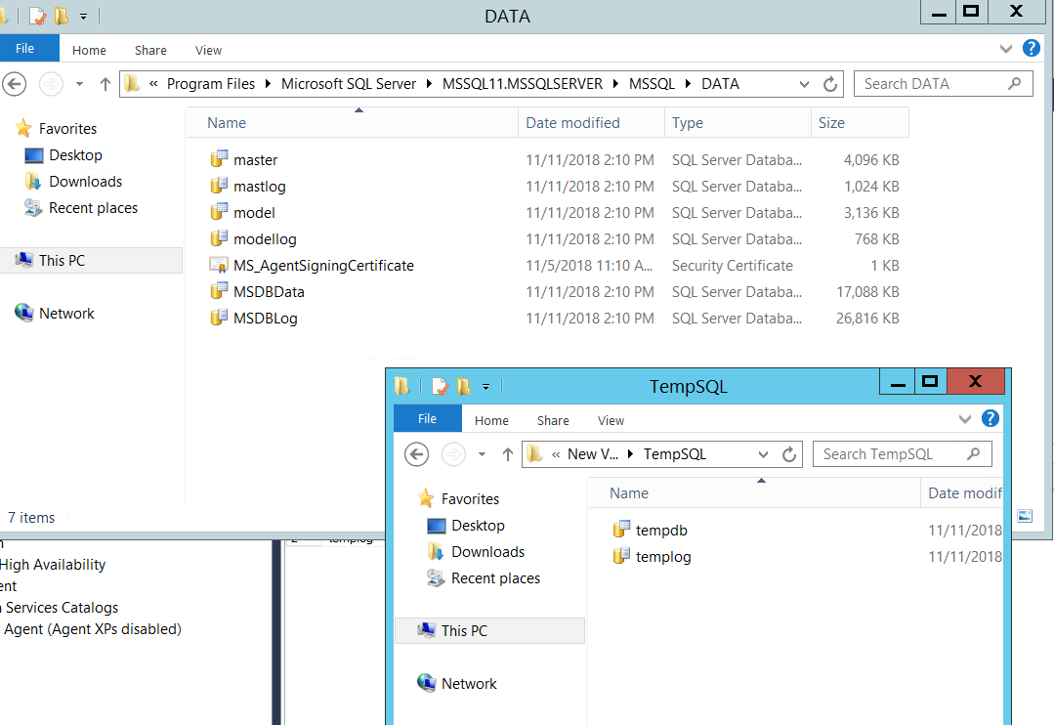

**Extra option:**

Script it using PowerShell:

Code should be wrapped in PowerShell script, started from student local PC, Password isn’t provided as a plain text, errors capturing is active, code returns DB files locations before execution and after, check the existing files with the same name in the target location, and check free space on disk. To check DB with TSQL:

SELECT name, physical_name,size,max_size,growth

FROM sys.master_files

WHERE database_id = DB_ID(N'tempdb');

Результат выполнения скрипта [SQL_LAB]_LAB2_Drozd_Task1

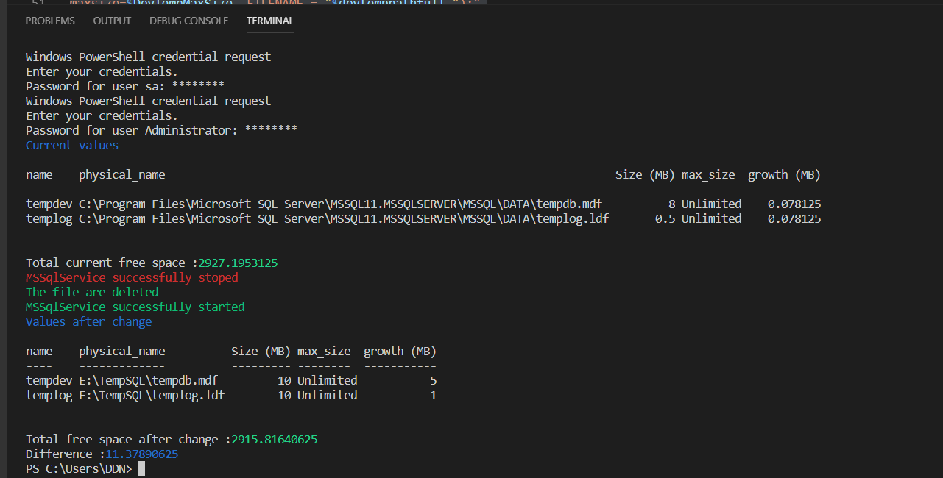

1. Create the **HumanResources** Database and the **InternetSales** Database:

|  |  |  |  |  |
| --- | --- | --- | --- | --- |
| Logical Name | Filegroup | Initial Size | Growth | Path |
| HumanResources | PRIMARY | 50 MB | 5MB/Unlimited | D:\Data\HumanResources.mdf |
| HumanResources_log |  | 5 MB | 1 MB/Unlimited | D:\Logs\HumanResources.ldf |
| InternetSales | PRIMARY | 5 MB | 1 MB / Unlimited | D:\Data\InternetSales.mdf |
| InternetSales_data1 | SalesData | 100 MB | 10 MB / Unlimited | D:\Data\InternetSales_data1.ndf |
| InternetSales_data2 | SalesData | 100 MB | 10 MB / Unlimited | D:\AdditionalData\InternetSales_data2.ndf |
| InternetSales_log |  | 2 MB | 10% / Unlimited | D:\Logs\InternetSales.ldf |
| Make the **SalesData** filegroup the default filegroup | | | | |

С помощью SSMS создаем HumanResources согласно требованиям(Предварительно создаем нужные каталоги для базы)

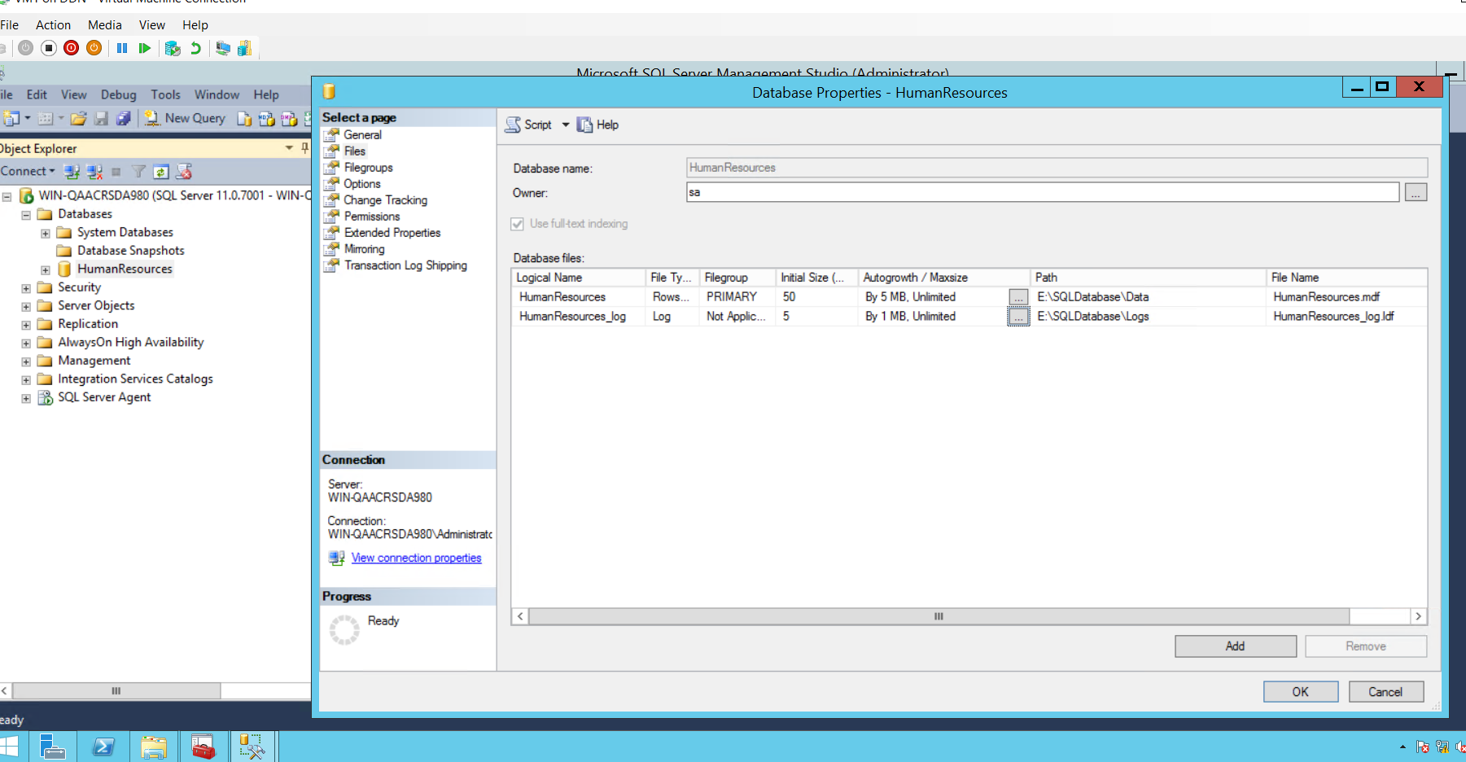

С помощью SSMS создаем InternetSales согласно требованиям

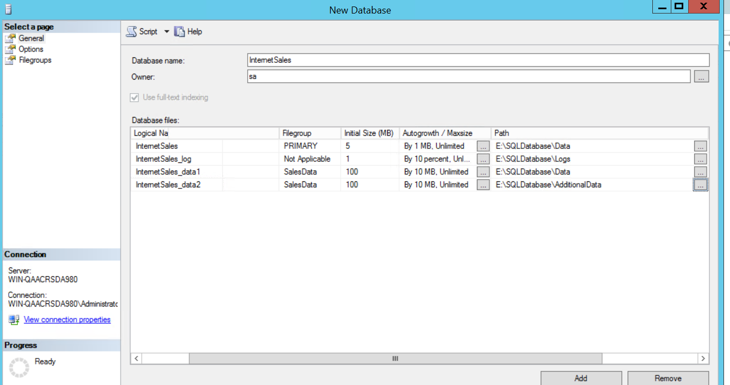

Делаем группу SaleDAta дефолтной для INternetSales

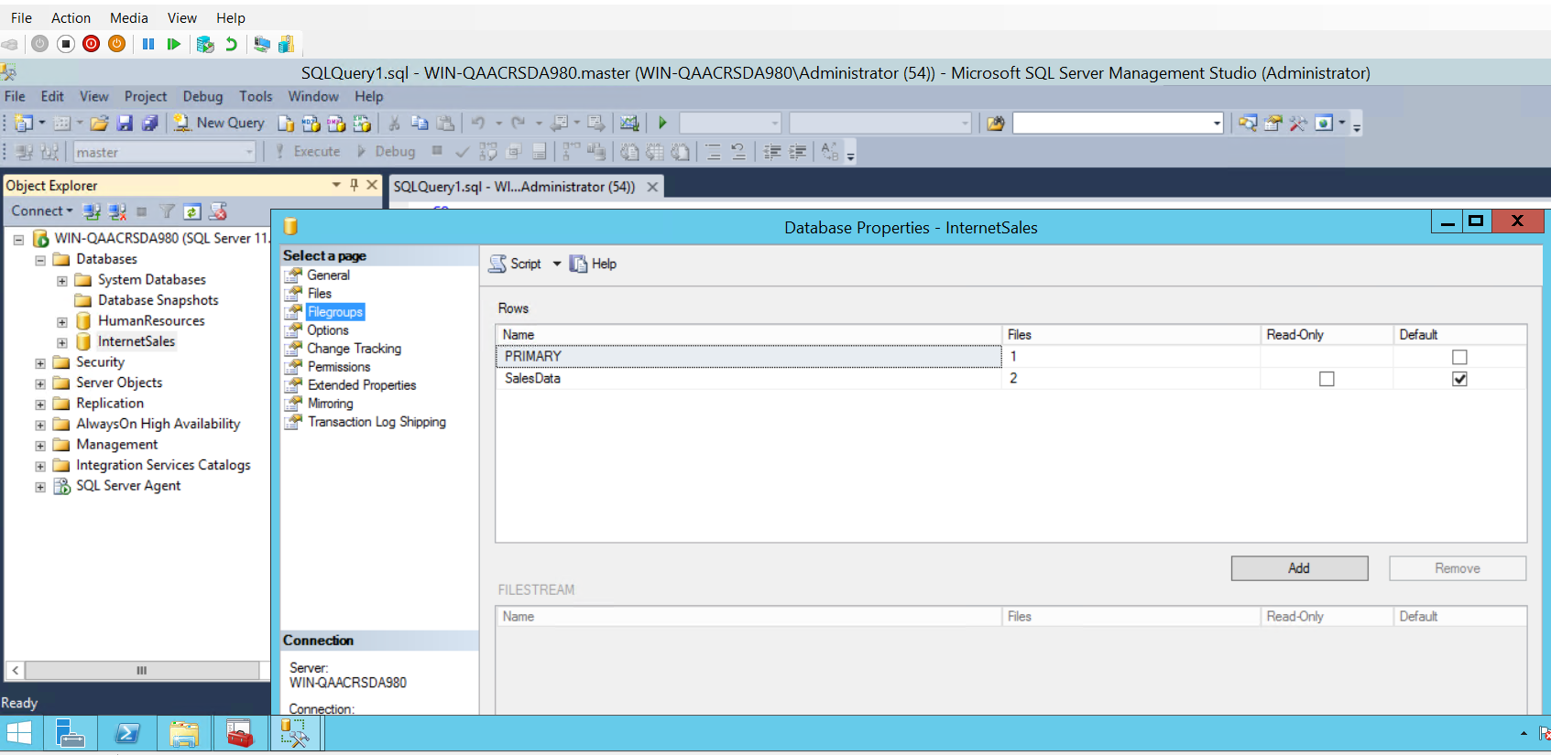

Проделываем тоже самое (на примере InternetSales) с помощью TSQL

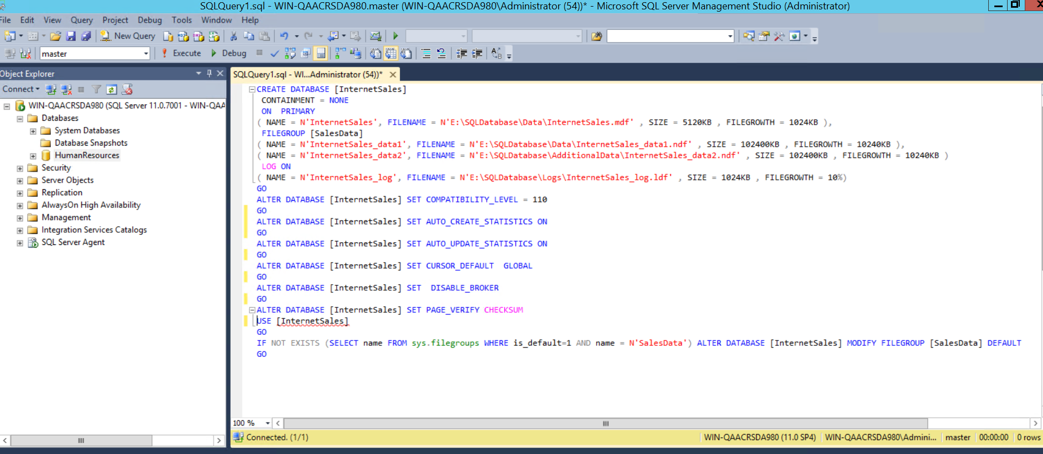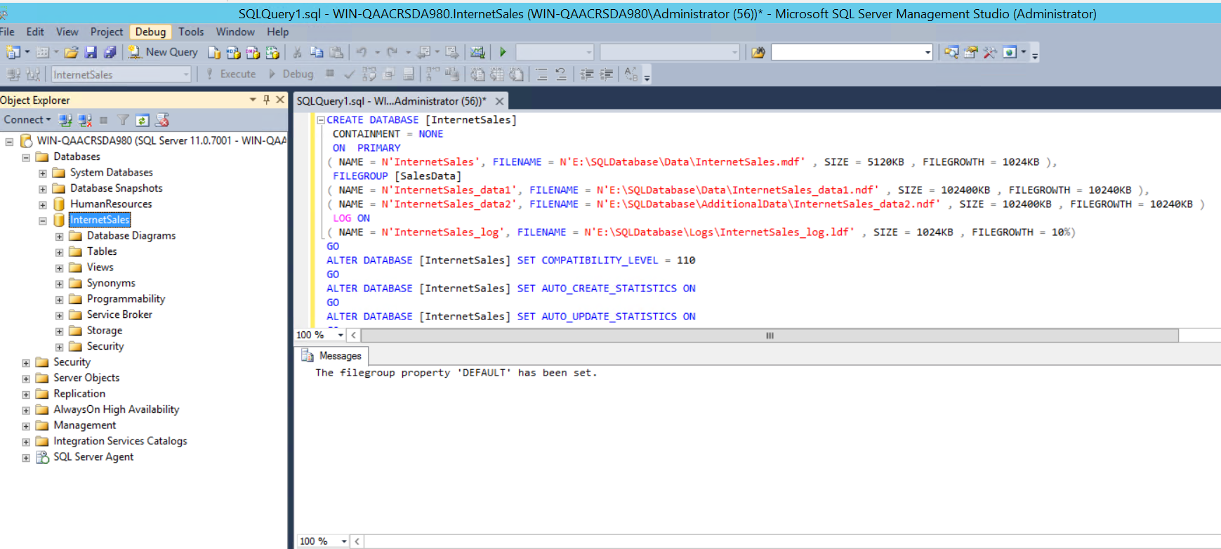

Проверяем свойства созданной базы

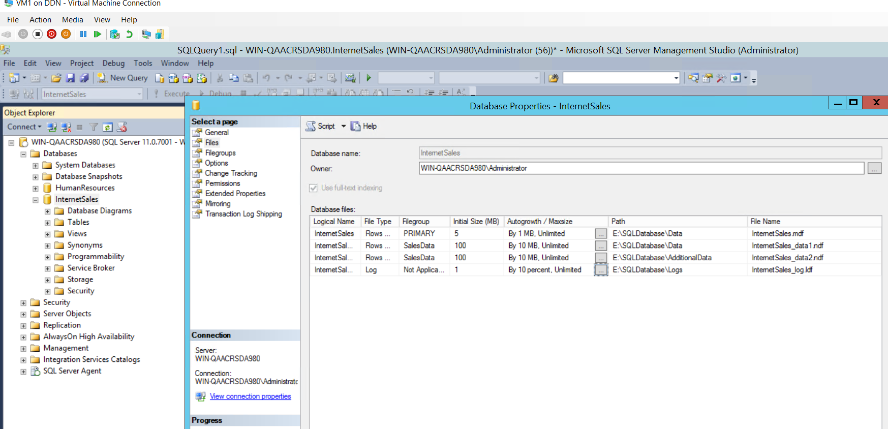

Check usage of created DBs space:

USE InternetSales;

GO

SELECT SUM(user_object_reserved_page_count) AS [user object pages used], (SUM(user_object_reserved_page_count)*1.0/128) AS [user object space in MB]

FROM sys.dm_db_file_space_usage;

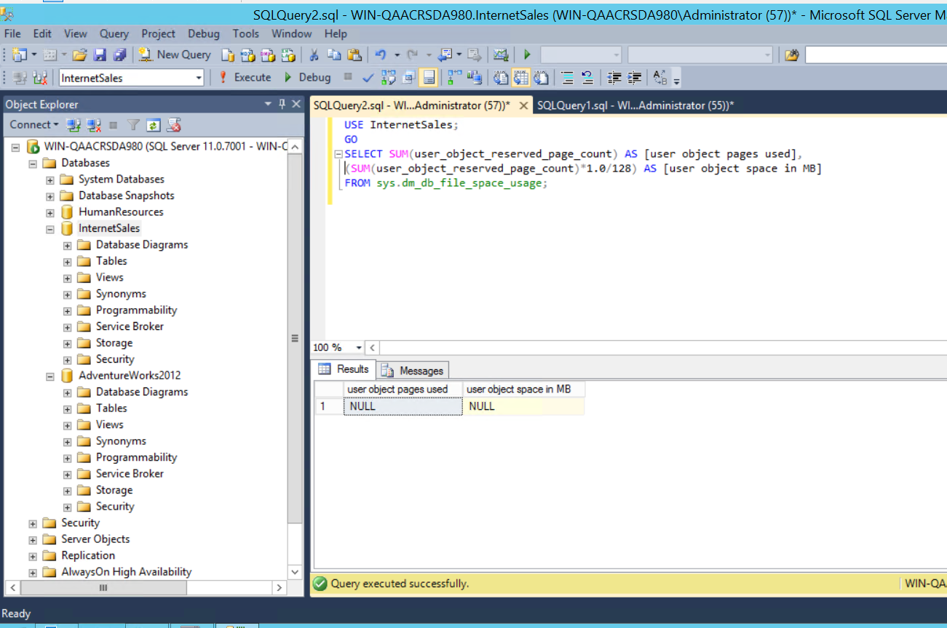

**Extra task:**

1. Wrap DBs creation in PS Script, lab task 2 should be executed as non-stop script with Human readable output, all scripts start from Student local PC. Check if DBs with such names already exist, if yes – drop them with their files, check if everything was succesfull, and create new DBs. NO REMOTE PS SESSIONS or invoke-expressions on remote PC.

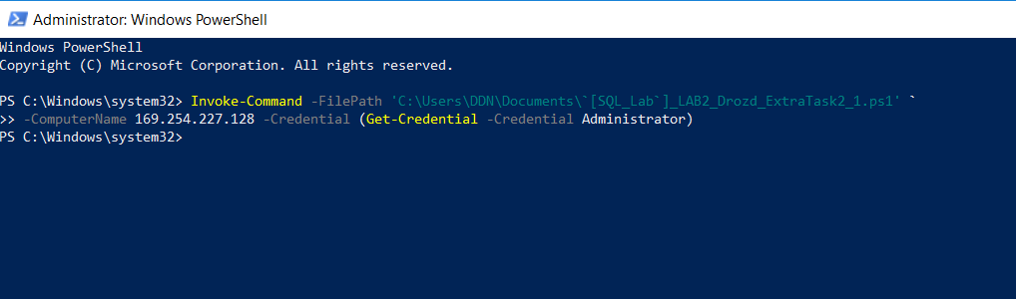

1. Using PowerShell, create and run script from local PC, which deploys:

Data Base “PCDRIVE” (with parameters like HumanResources)

DB contains tables with results of command:

Get-PhysicalDisk | select -Property FriendlyName,BusType,HealthStatus,Size,MediaType

Data types and names for columns could be selected by yourself

Compare pages and files sizes before and after filling data to DB (PS Script should show it in Human readable format).

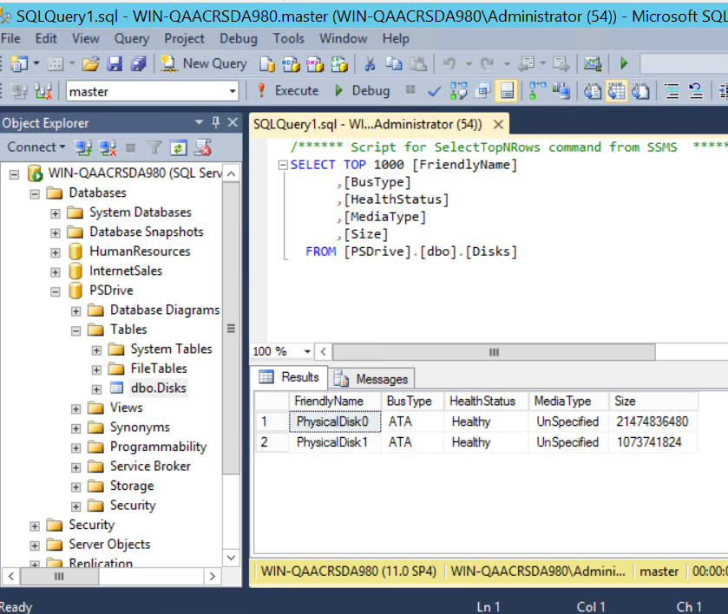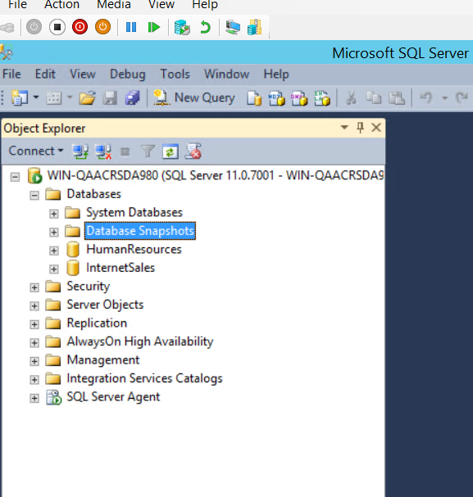Save logging of script actions with start and stop time of execution. (Decide what should be logged – it is your own choice).

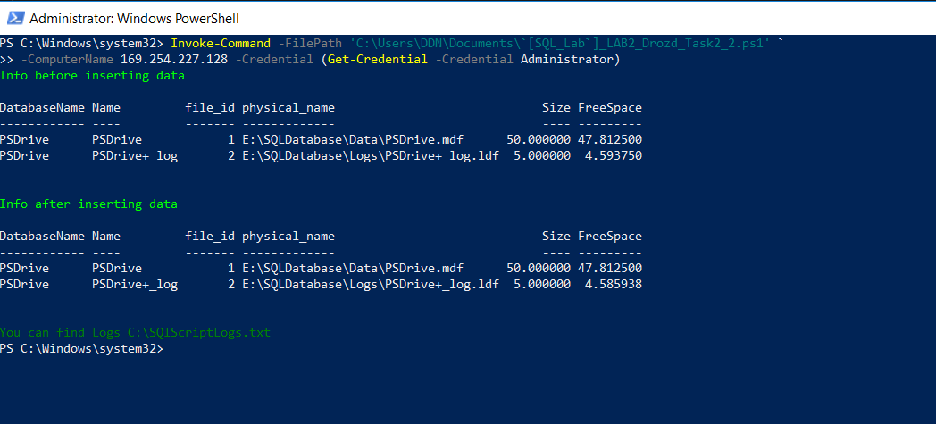

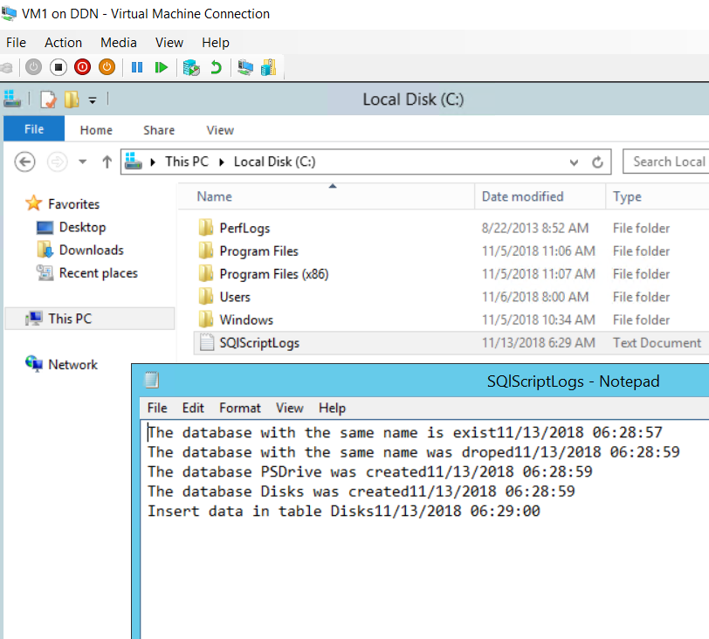

1. Attach database “AdventureWorks” from the provided source. Place files in the new created folder on Data disk. Answer the question if Database could be attached if you create a new database using provided files. Make screenshots of the process for report.

**Answer:** NO

